Lab File

BASIC ELECTRONICS ENGINEERING

(ES 201)

DEPARTMENT OF COMPUTER SCIENCE AND ENGINEERING

Submitted to: Submitted By:

Ms Manisha Chahande Prerna, Amrit, Kunal, Tanya, Shaina

Ast. Professor 3CSE 4Y

ECE Department A2305219264, A2305219292

A2305219293, A2305219295,

A2305219268

Amity School Of Engineering and technology

Amity University Uttar Pradesh

Noida -201301

**OPEN ENDED EXPERIMENT**

**AIM -** To design a voltage regulator using Zener diode that will maintain a constant output across load resistor with a variable dc input voltage. Also calculate maximum Zener current and power.

# THEORY-

A Zener Diode is a special kind of diode which permits current to flow in the forward direction as normal, but will also allow it to flow in the reverse direction when the voltage is above the breakdown voltage or ‘Zener’ voltage. Zener diodes are designed so that their breakdown voltage is much lower.

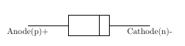

***P-N JUNCTION DIODE SYMBOL***

***P-N JUNCTION DIODE***

**Function of Zener Diode**

1. Zener diodes are a special kind of diode which permits current to flow in the forward direction.
2. Zener diodes will also allow current to flow in the reverse direction when the voltage is above a certain value. This breakdown voltage is known as the Zener voltage. In a standard diode, the Zener voltage is high, and the diode is permanently damaged if a reverse current above that value is allowed to pass through it.
3. In the reverse bias direction, there is practically no reverse current flow until the breakdown voltage is reached. When this occurs, there is a sharp increase in reverse current. Varying amount of reverse current can pass through the diode without damaging it. The breakdown voltage or Zener voltage (VZ) across the diode remains relatively constant.

# Zener Diode I-V Characteristics Curve

In the forward bias condition, the Zener diode behaves like an ideal diode within specified current and power limits, but it differs in reverse bias condition where the zener diode has very steep avalanche characteristic at the breakdown voltage in reverse bias condition.

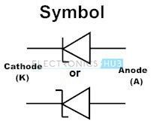

Zener operates mainly in the reverse bias mode by connecting anode to the negative terminal of the power supply. Zener diodes are categorised and rated by the voltage at which they will turn on or start to conduct the reverse bias current.

The maximum power intended for a Zener diode is specified as Pz=VzIz max and it is a function of the plan and structure of the diode. The knee of the curve is generally approximated as 10% of Iz max, i.e., Iz min=0.1Izmax.

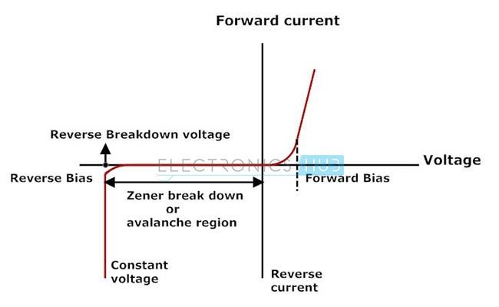

***ZENER DIODE I-V CURVE***

Generally, these Zener diodes are used to regulate the voltage. In reverse bias condition after the break down Zener diode provides a constant output voltage even if we increase the input voltage. There are specifically two separate mechanisms that might cause a breakdown in a Zener diode:

## Avalanche Breakdown

It is predominant above approximately 5.5 volts. This mechanism is also referred to as impact ionisation or avalanche multiplication. For reverse conduction it is necessary to visualise the phenomenon of avalanche breakdown. This process begins when a large negative bias is applied to the PN junction, sufficient energy is imparted to thermally generated minority charge carriers in the semiconductors.

As a result, the free carriers acquire required kinetic energy to break the covalent bonds and create an electric field through collisions with crystal particles. The charge carriers created in collision contribute to the reverse current, well beyond the normal reverse saturation current and may also possess enough energy to participate through collisions, creating an additional electric field and the avalanche effect by impact ionization, once a sufficiently high reverse bias is provided this process of conduction takes place very much like an avalanche: a single electron can ionise several others.

## Zener Breakdown

It is predominant below approximately 5.5 volts. This mechanism is also referred to as a high field emission mechanism. The phenomenon of Zener breakdown is related to the concept of avalanche breakdown. Zener breakdown is achieved by heavily doped regions in the neighbourhood of ohmic contact.

It is the second method of disturbing the covalent bonds of the crystal atoms and increasing the reverse bias Zener diode current, to be sustained at a much lower specific voltage than normal diode. The reverse bias voltage known as Zener voltage, where this mechanism occurs is determined by the diode doping concentration and it occurs when the depletion layer field width is sufficiently enough to disrupting the covalent bonds and cause number of free charge carriers due to electric field generation to swell.

The true Zener effect in semiconductors can be explained in terms of two upper energy bands are of interest. The two upper energy bands are namely the conduction band and the valence band.

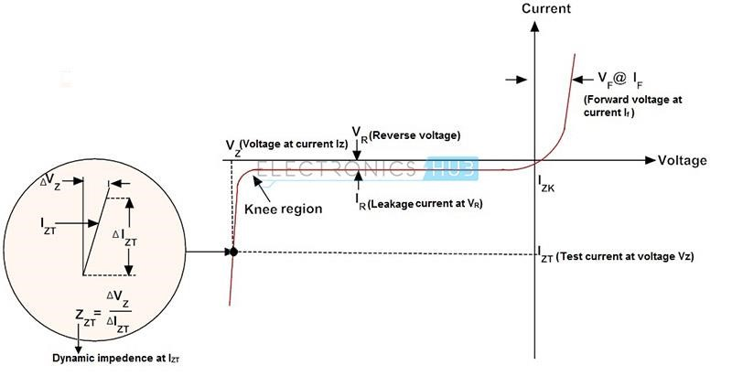

Either of these effects or a combination of the two mechanisms significantly increases the current in the reverse bias region while having a negligible effect in the voltage drop across the junction. When the applied reverse bias voltage is greater than a predetermined voltage, Zener breakdown takes place.

The Zener breakdown voltage is made sharp and distinct by controlling the doping concentration and when surface imperfections are avoided. The voltage across the Zener diode in breakdown region is almost constant that turns out to be an essential concept in regulating the voltage.

**Zener Diode as Voltage Regulators**

The function of a regulator is to provide a constant output voltage to a load connected in parallel with it in spite of the ripples in the supply voltage or the variation in the load current and the Zener diode will continue to regulate the voltage until the diodes current falls below the minimum IZ(min) value in the reverse breakdown region. It permits current to flow in the forward direction as normal, but it will also allow it to flow in the reverse direction when the voltage is above a certain value - the breakdown voltage known as the Zener voltage. The Zener diode specially made to have a reverse voltage breakdown at a specific voltage. Its characteristics are otherwise very similar to common diodes. In breakdown the voltage across the Zener diode is close to constant over a wide range of currents thus making it useful as a shunt voltage regulator.

The purpose of a voltage regulator is to maintain a constant voltage across a load regardless of variations in the applied input voltage and variations in the load current. A typical Zener diode shunt regulator is shown in Figure 3. The resistor is selected so that when the input voltage is at VIN(min) and the load current is at IL(max) that the current through the Zener diode is at least Iz(min). Then for all other combinations of input voltage and load current the Zener diode conducts the excess current thus maintaining a constant voltage across the load. The Zener conducts the least current when the load current is the highest and it conducts the most current when the load current is the lowest.

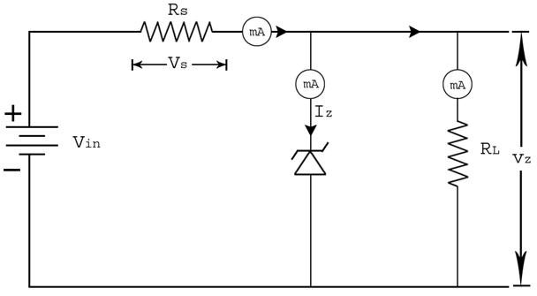

***ZENER DIODE SHUNT REGULATOR***

If there is no load resistance, shunt regulators can be used to dissipate total power through the series resistance and the Zener diode. Shunt regulators have an inherent current limiting advantage under load fault conditions because the series resistor limits excess current.

 A Zener diode of break down voltage VZ is reverse connected to an input voltage source Vi across a load resistance RL and a series resistor RS. The voltage across the Zener will remain steady at its break down voltage VZ for all the values of Zener current IZ as long as the current remains in the break down region. Hence a regulated DC output voltage V0 = VZ is obtained across RL, whenever the input voltage remains within a minimum and maximum voltage.

Basically, there are two type of regulations such as:

### a) Line Regulation

In this type of regulation, series resistance and load resistance are fixed, only input voltage is changing. Output voltage remains the same as long as the input voltage is maintained above a minimum value.



Percentage of line regulation can be calculated by =

where V0 is the output voltage and VIN is the input voltage and ΔV0 is the change in output voltage for a particular change in input voltage ΔVIN.

### b) Load Regulation

In this type of regulation, input voltage is fixed and the load resistance is varying. Output volt remains same, as long as the load resistance is maintained above a minimum value.



Percentage of load regulation =

where VNL is the null load resistor voltage (ie. remove the load resistance and measure the voltage across the Zener Diode) and VFL is the full load resistor voltage

### **Design a Voltage Regulator**

When selecting the Zener diode, be sure that its maximum power rating is not exceeded.

IMAX = Maximum current for Zener diode



Vz = Zener Diode Standard Voltage

Vin = Input Voltage

Vs = Voltage across Series Resistance

VL = Voltage across Load Resistance

IS = Current Passing through Series Resistance

Iz = Current Passing through Zener Diode

IL = Current Passing through Load Resistance

**Calculating Voltage and Current**

The total current drawn from the source is the same as that through the series resistor



The current through the load resistor is



 and the zener diode current is



If the voltage source is greater than Vz

  and  

If the voltage source is less than Vz

   and    

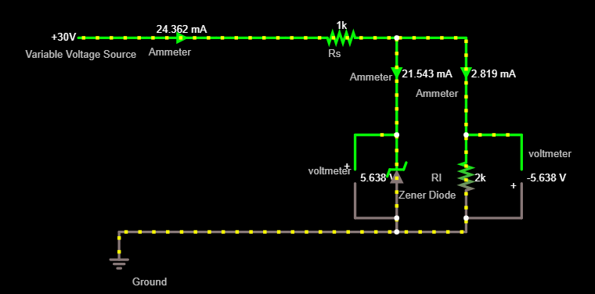

***CIRCUIT DIAGRAM FOR ZENER DIODE AS VOLTAGE REGULATOR***

**CALCULATIONS-**

Min DC supply voltage, Vmin = 0 Volts

Max DC supply voltage, Vmax = 30 Volts

Load resistance RL =2000 Ohm

Rs = 1Kilo Ohms

Total min current, IRmin = 0mAmpere

Total max current, IRmax = 24.36mAmpere

Max Zener voltage, VZM = 5.36 Volts

Load Current, IL= VL/RL=2.819 Ma

Max Zener current, IZM = IRmax - IL = 21.543mA

Power, PZM = VZM IZM = 122.42mWatt

**RESULT-**

Maximum Zener current, Izm = IRmax- IL= 21.543mA

Power associated by Zener diode, PZM = VZMIZM = 122.42mWatt

**CONCLUSION-**

We have successfully implemented Zener Diode as a Voltage Regulator and its maximum current passing through it and power dissipated by it.